Hydroinformatics
Individual Learning Opportunity 6

Automation of Data Management Tasks

Due Date: October 25th

Learning Objectives
- Learn the basic concepts of data management automation using Python.
- Learn Python scripting using the ArcPy module for automation of geospatial data management and analysis tasks.
- Learn Python scripting using the PyODBC module for automation of SQL Server based data management tasks.

Computer and Data Requirements
- Data: The Little Bear River ODM database.
- Software: Microsoft SQL Server access, ESRI ArcGIS 10.0 or 10.1, PyODBC. Please refer to the PPT slides presented in class for the relevant URL’s to get this software.

The Problem
Let’s consider the scenario in which you have accessed a number of time series observation weather data station files from the Utah Climate Center web site and you would like to automate the activity of reading them, parsing them, and uploading them into an ODM style database on Microsoft SQL Server. You may also want to estimate the spatial distribution of the parameter in question and generate a large PDF file with a series of custom maps showing your interpolated variable. This is a perfect problem for the tools we studied this week – Python coding using ArcPy and PyODBC!

Deliverable
Upload 10-15 weather station precipitation data files to your ODM database on SQL Server. Download data for all sites for a single year. Automatically generate a PDF file with 12 maps of interpolated precipitation data for a region of interest in Utah. Prepare a onepage report of your effort and attach the Python script you wrote, and your final PDF file of maps as an appendix.
Suggested Approach
- Gather a 10 - 15 precipitation data files from the Utah Climate Center for various weather stations in an area of interest to you. You can find the data here: http://climate.usurf.usu.edu/mapGUI/mapGUI.php. You need to zoom in quite far before the climate stations show up on the map. To download the precipitation files, you need to click on a site and it will add that site to a sidebar on the right showing your Selected Stations. In the Selected Stations window, click the histogram icon to open reports for that station.
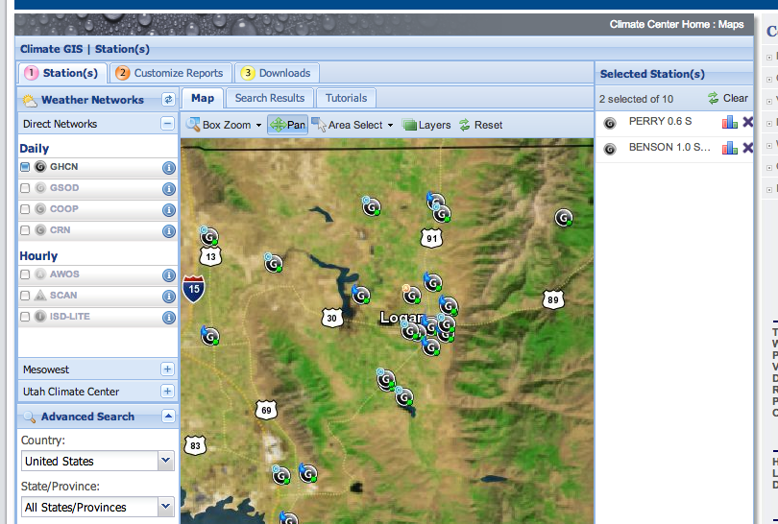
- In the dialog window that opens under “Select a Report” choose “Precipitation”. Then click “Get Report”. This will open a web page showing you precipitation data for that site. Next you can click “Export this report as a spreadsheet” to download a text file of the data at this site. NOTE: The CSV file does NOT contain latitude and longitude for the site, even though it is displayed in the web page. So copy the latitude and longitude data and paste it into your CSV files, immediately after the station name. Then you can import that information into your Python script and use it to add new sites to your ODM database.
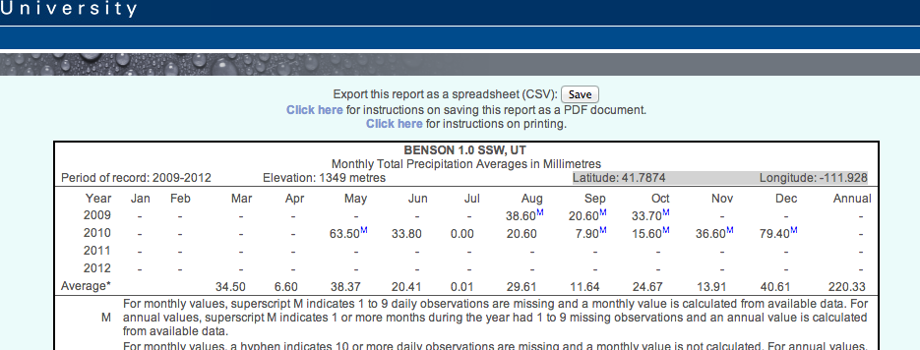
- Here is what my CSV files look like after I add the latitude and longitude to them:
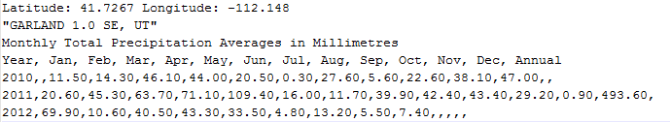
- Write a Python script to search a folder on your computer for all of the files you downloaded, then read and parse these files and upload the relevant metadata and time series data to your ODM database. This will include creating a new site in the sites database and giving it the latitude and longitude from the CSV file as well as the name of the site. You will also be adding data to the values table.
- Next, write a Python script to query your ODM database for all the precipitation in each of 12 months in a single year of your choosing. For each month you query, download the precipitation at each station for that month/year and create a point shapefile from these. Call an appropriate ArcPy interpolation function to make an interpolated precipitation map. Add this to a PDF file.
- Try to generate a single PDF file with interpolated precipitation maps for all 12 months The approaches to using Google Fusion Tables and Esri Maps for Office were both presented in class and are available to review as videos of the class lectures.
A complete sample script for parsing and uploading data to your ODM databasd using PyODBC is available on the course web site here: https://usu.instructure.com/courses/127332/files/23303746/download?wrap=1

